22201502

Abdullah al mahmud

Task 1: Wireshark

**HTTP request**

# Frame :

Frame 1765 contains data from the application layer which has been encapsulated in the transport layer and later carried over to the network layer. Frames are the PDU of the data link layer. A header and tail is added with the frame. Send the frame straight to the destination device.

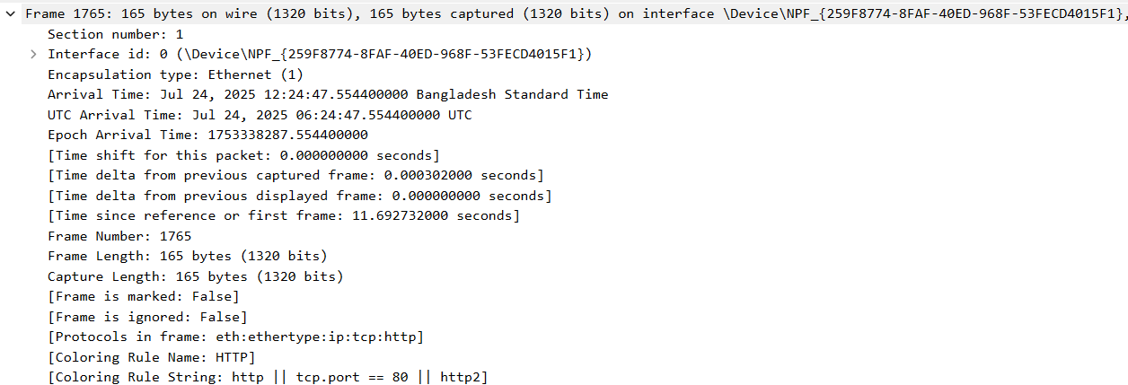

Ethernet II:

The data link layer contains the source MAC address: (a8:93:4a:9c:ad:7d) and destination MAC address (c0:f6:ec:90:a9:0b) needed to identify the source and destination device within a network .

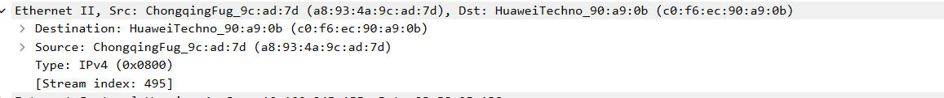

Internet protocol:

The network layer is using Internet protocol source ip address: (10.100.245.155) destination ip address (23.58.95..138) are used to identify a device uniquely. This is responsible for routing and sending packers from source to destination.

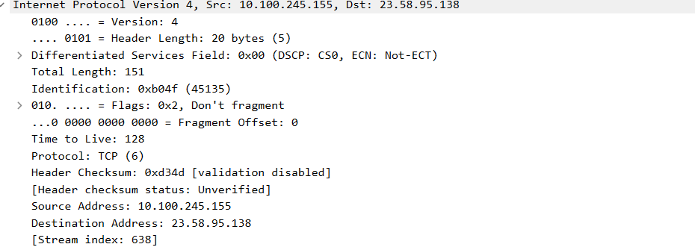

Transmission control protocol:

The transport layer is using TCP as its protocol with source port 7287 destination port 80 sequence number 1 acknowledgement number 1. The control flags are set accordingly. The port address is used for process to process data transmission.

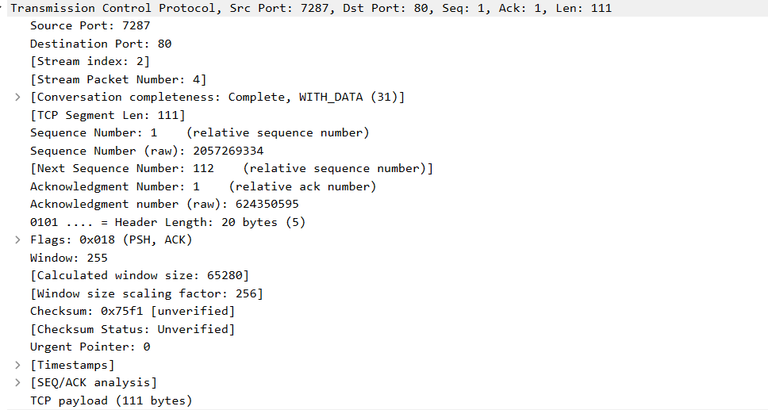

Hypertext transfer protocol:

Here it refers to HTTP version 1.1 is used as the HTTP protocol which uses persistence HTTP connection. The header contains the response related contents as well.

